press release

24th August 2018
page 1 of 1
FORBO: THE HEALTHCARE FLOORING SPECIALISTS

With a strong commitment to healthy interior environments, Forbo Flooring Systems will be showcasing its portfolio of floor coverings that are ideally suited to healthcare settings at this year’s Healthcare Estates Exhibition.

Located on stand D17, Forbo’s products are designed to be good for people, buildings and the environment, with a wide range of solutions to cater for all healthcare applications. What’s more, as a recently appointed supplier on the ProCure22 framework, specifiers, contractors and estate managers across NHS England can rest assured that Forbo’s flooring solutions are both approved and affordable for the healthcare environment.

Forbo will be showcasing its integrated product portfolio, which includes the new adhesive free Modul’up vinyl range. Quick and easy to install, this floor covering can be walked on immediately after installation, making it ideal for applications where downtime needs to be minimised. Other products on display include the ever-popular Marmoleum, which is naturally bacteriostatic and helps prevent hospital acquired infections; Sphera, a SMART top homogeneous vinyl; and STEP safety vinyl, which features innovative clear Step crystals.

In keeping with the trend towards more design-oriented interiors within clinical environments, Forbo will also be showcasing its digitally printed Eternal vinyl – a truly unique floor choice that allows specifiers to create bespoke designs using their own digital imagery. This option is perfectly suited to children’s wards and patient wellbeing areas.

Finally, Forbo will also be presenting Bulletin Board, it’s ‘off the floor’ solution that is ideal for use behind patients’ beds and for protecting walls in high traffic areas that are likely to be knocked by moving trollies and beds.

Forbo’s specialists will also be on-hand to advise on the company’s added value services, such as its collaborative work with The University of Stirling’s Dementia Services Development Centre (DSDC.) Forbo has been working in partnership with the DSDC for the last two years to review and accredit its floors in relation to dementia design principles and usability within a dementia-inclusive environment. Consequently, more than 1000 of Forbo’s products have been accredited.

Mark Jackson, Key Account Manager at Forbo Flooring Systems commented: “Forbo is deeply committed to developing products that contribute in a positive way to the health and comfort of individuals. With 2018 marking both the 70th anniversary of the NHS and the 75th anniversary of the Institute of Healthcare Engineering and Estate Management, the issues being discussed at this year’s exhibition have never been so topical – and we’re looking forward to this opportunity to engage with the sector.”

Healthcare Estates is an annual 2-day event that focuses on the funding, design, build, management and maintenance of healthcare facilities across the country. The event combines the IHEEM (Institute of Healthcare Engineering and Estate Management) annual conference and exhibition.

For more information please visit www.forbo-flooring.co.uk/healthcare or for dementia friendly products www.forbo-flooring.co.uk/designingfordementia

-ENDS-

Image | Information
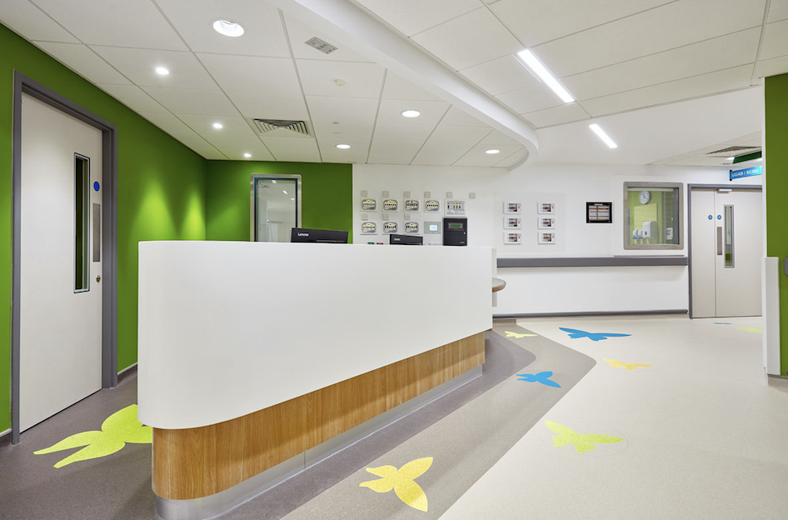 | Sphera Element in Mortar 50018, Teal 50046, Amber 50054 and Yellow Green 50049

NOT FOR PUBLICATION:

For further press information and approval of colour separation charges, please contact Annabelle Kay at CIB on Tel: 01372 371800, Fax: 01372 371 801 or Email annabellek@cibcomms.co.uk

Please forward all reader enquiries to:
Gerry Cherry
CIB
Riversway
Leatherhead Bridge
Guildford Road
Leatherhead
Surrey
KT22 9AD
Tel: 01372 371800
Fax: 01372 371801
Email: pradmin@cibcomms.co.uk

